**Year 9 English Curriculum Map**

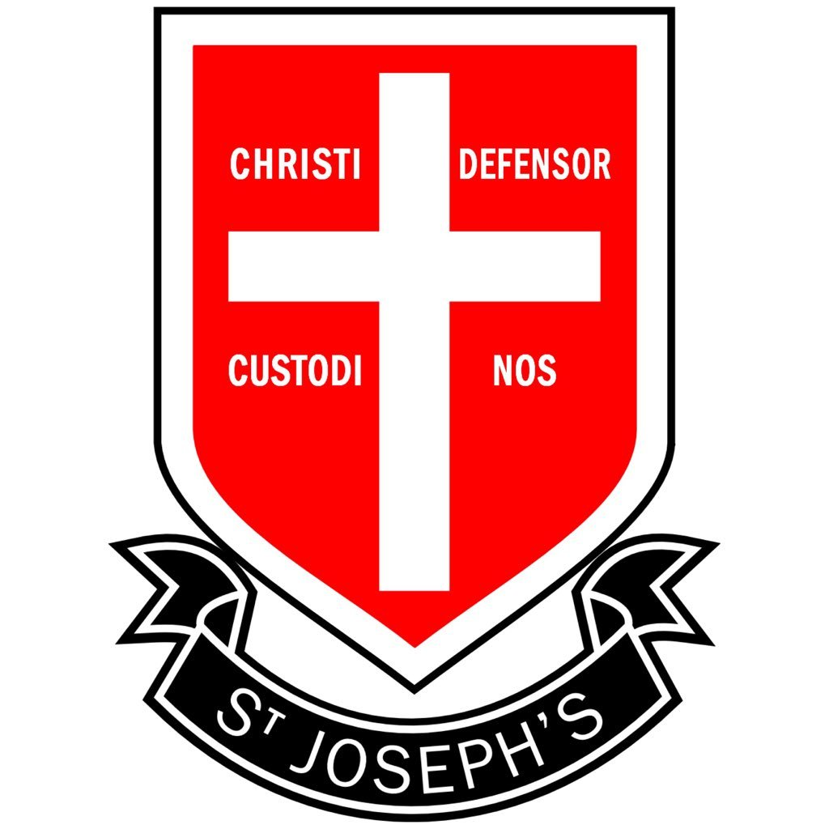

**Summer 2**

**The Strange Case of Dr Jekyll and Mr Hyde**

* You will study Robert Louis Stevenson’s gothic novella about the complexities of science and the duplicity of human nature.

**Summer 1**

**Pigeon English**

* You will study Stephen Kelman’s novel which is told from the point of view of Harrison Opoku, an eleven-year-old Ghanaian immigrant living on a tough London estate.

**Spring 2**

**Love Poetry**

* You will be studying a selection of love poems from different eras and cultures.
* You will examine how poets use a range of devices and forms and consider their effects on the reader.

**Spring 1**

**The Merchant of Venice**

* You will study Shakespeare's play which explores prejudice, social injustice, money and love.

**Autumn 2**

**Weeks 1-3: Lord of the Flies**

**Weeks 4-6: The Merchant of Venice (9 weeks)**

* You will study Shakespeare's play which explores prejudice, social injustice, money and love.

**Autumn 1**

**Lord of the Flies (9 weeks)**

* You will study William Golding’s

famous novel which focuses on a group of British boys stranded on an uninhabited island and their disastrous attempt to govern themselves.