**Year 8 English Curriculum Map 2020-21**

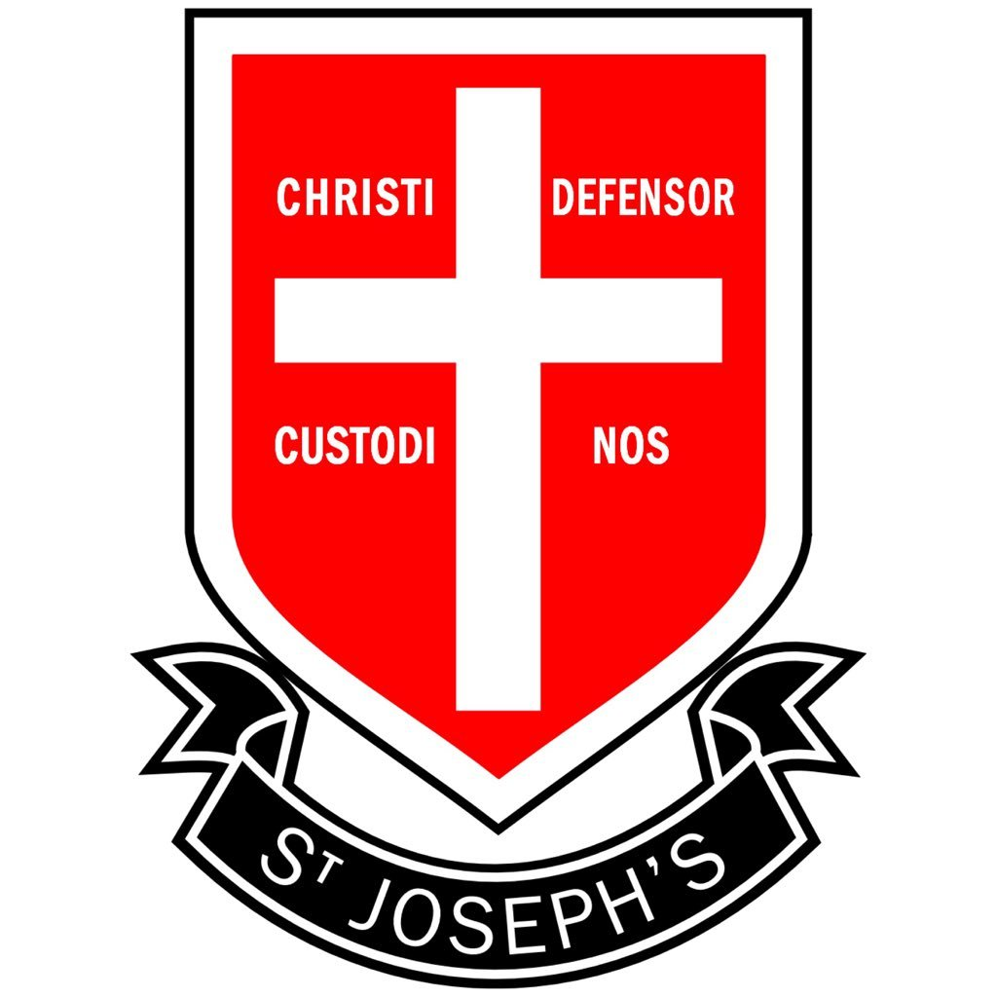

**Summer 2**

**‘Of Mice and Men’ By John Steinbeck**

* You will study this famous American novel set during the Great Depression, focusing on the lives of migrant workers.
* You will examine how Steinbeck presents themes of friendship, loneliness, dreams and prejudice.

**Summer 1**

**Gothic with S&L focus**

* You will study different features of the gothic genre, exploring key characters, themes and motifs.

**Spring 2**

**World War 1 Poetry**

* You will explore the significance of poetry during WW1. You will examine how poetry was used as a form of propaganda and also how it was used by soldier poets, including Owen and Sassoon, to reveal the true horrors of war.

**Spring 1**

**Diverse Literary Shorts**

* You will study a richly diverse range of texts to promote critical thinking.
* You will explore challenging material by renowned authors writing about issues important to the world today.

**Autumn 2**

**Shakespearean Comedy**

* You will study one of Shakespeare’s comedy plays and explore comedic themes in his work, including unrequited love, mistaken identities and family tensions.

**Autumn 1**

**Non-fiction shorts**

* You will be studying a selection of non-fiction texts on a range of topics.
* You will examine how writers adapt their work to suit different text types, audiences and purposes.