**Year 7 English Curriculum Map 2020-21**

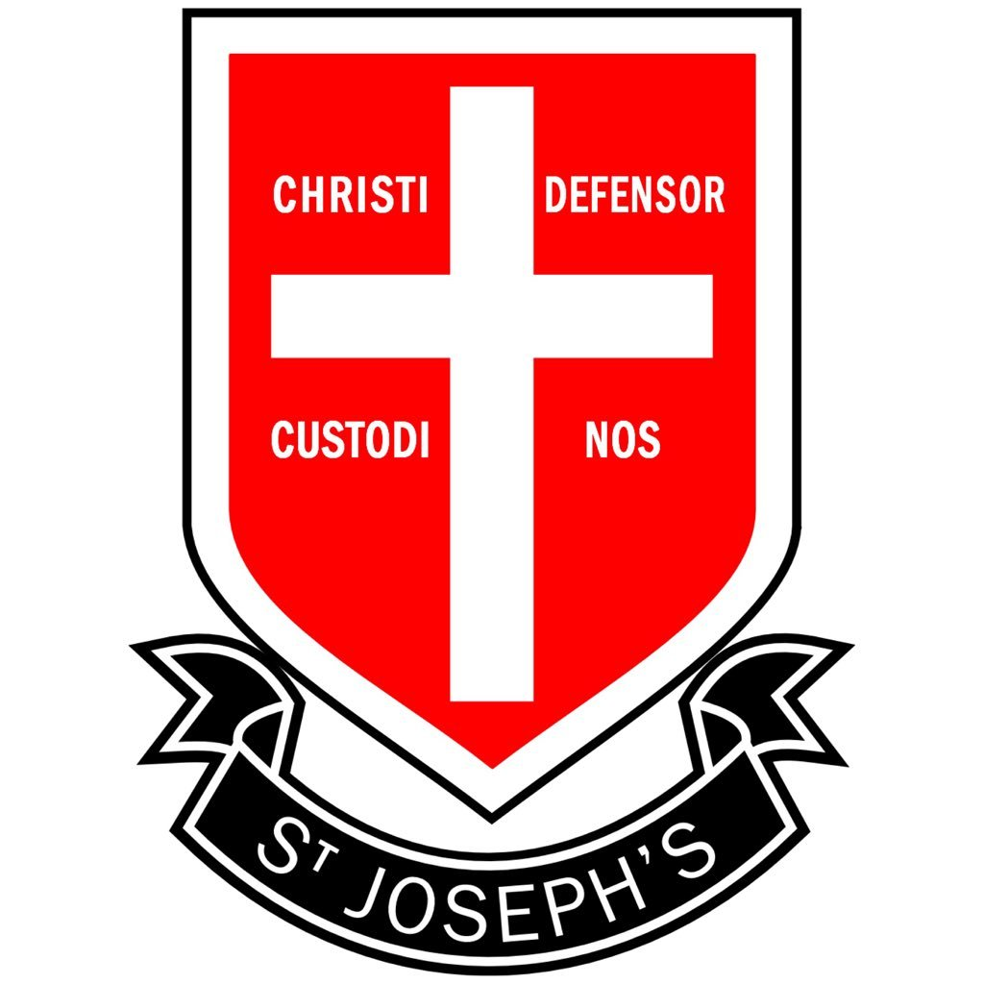

**Summer 2**

**19th Century Literature**

* You will examine the Victorian era and its impact on literature.
* You will study work from a range of Victorian writers, with a particular focus on Charles Dickens.

**Summer 1**

**‘Moon on the Tides’ Poetry anthology**

* You will study a collection of poems exploring a range of themes and ideas, including: homelessness, loss, love, friendship, experiences growing up and family relationships.

**Spring 2**

**Introduction to the works of William Shakespeare**

* You will explore the world in which Shakespeare was writing, examining how Elizabethan and Jacobean audiences responded to his work.
* You will analyse the portrayal of characters and themes within his plays.

**Spring 1**

**Non-fiction shorts**

* You will be studying a selection of non-fiction texts on a range of topics.
* You will examine how writers adapt their work to suit different text types, audiences and purposes.

**Autumn 2**

**‘Wonder’ By R J Palacio**

* You will be studying a novel which focuses on the life of a resilient young boy who has had to overcome adversity in an attempt to lead a normal life.

**Autumn 1**

**Literary Shorts:**

* You will be studying a selection of short stories from different time periods, cultures and contexts.
* You will analyse how writers use language, form and structure to create meanings.